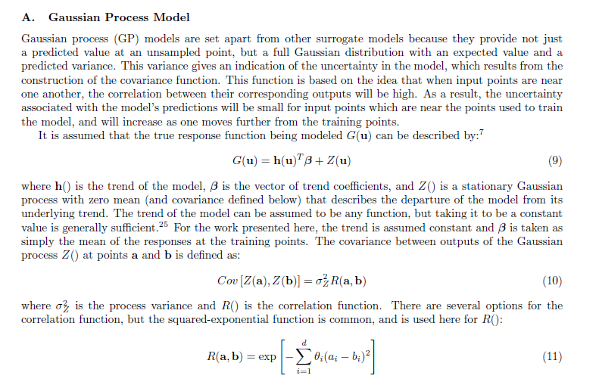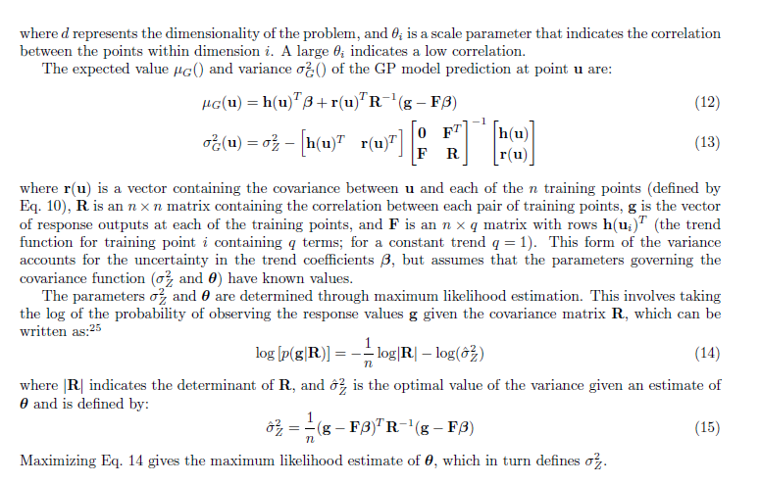

Bichon, B.J., M. S. Eldred, L. P. Swiler, Mahadevan, S., J. M. McFarland, “[Efficient Global Reliability Analysis for Nonlinear Implicit Performance Functions](http://pdf.aiaa.org/getfile.cfm?urlX=%2D%3CWI%277D%2FQKS%2B%28S0KKW%20%20%20%0A&urla=%26%2A%22D%23%23%20NA%0A&urlb=%21%2A%20%20%20%0A&urlc=%21%2A0%20%20%0A&urle=%28%2A%22H%26%220%2EEUA8%20%0A),” AIAA Journal, Vol. 46, No. 10, pp. 2459-2468, 2008.